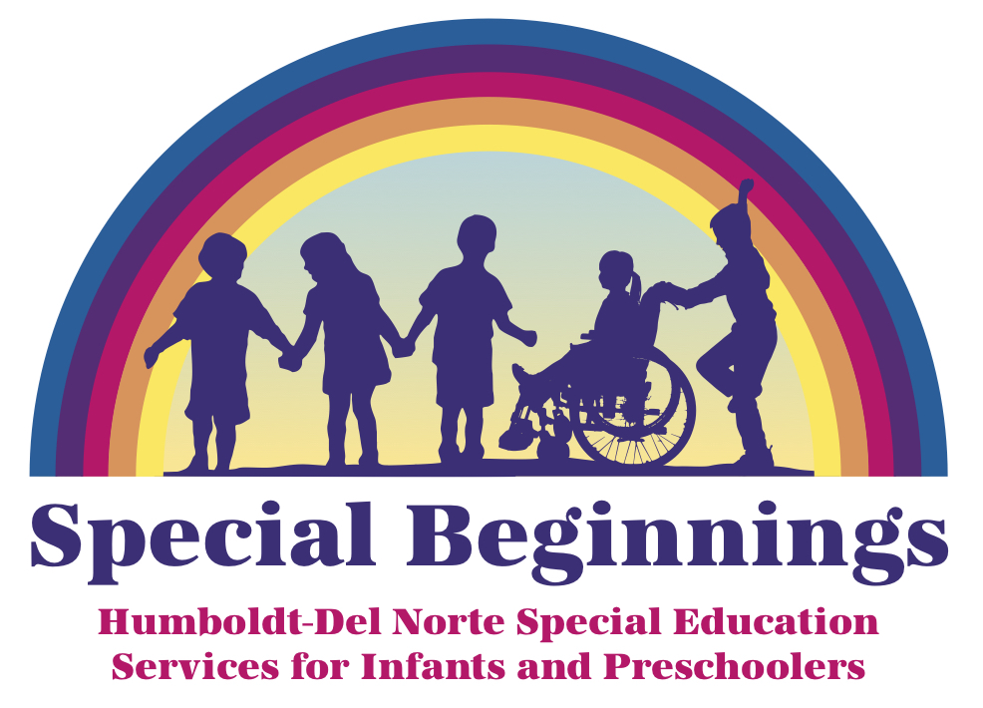 Developmental Inquiry Request
Special Beginnings/ Humboldt County Office of Education (HCOE)
901 Myrtle Ave. Eureka, CA 95501
(707)445-7043 FAX (707)445-7143
Dear Parent/Guardian:
We occasionally receive requests from parents and/or other family members, physicians, preschools, and the Redwood Coast Regional Center for a staff member from HCOE to look at a child’s development due to educational concerns. With permission, this request may include an observation at our site or your child’s natural environment, asking your child to perform a few learning-related activities such as copying a simple drawing, or answering questions designed to elicit language. Based on needs a formal educational observation tool may be used. This is typically a simple and quick process. This is not an assessment for eligibility for special education and related services and does not result in a determination regarding a child’s suspected disability and/or eligibility for special education services. If you would like a determination regarding whether your child is eligible for special education, please let an HCOE Staff Member know and we will coordinate with your school district of residence in that process. This form gives your permission for the HCOE Staff Member to observe and work with your child. We only complete requests for identified children when we believe the child could benefit from additional instructional strategies.

Child’s Legal Name __________________________________________ Child’s Date of Birth _____________________________
Child’s Gender: Male Female Non-Binary Parent/Guardian’s Name____________________________________________
Contact Number for Parent/Guardian: _________________________________ Email Address Parent/Guardian_______________________
Home Address/City of Child_________________________________________ Mailing Address if Different____________________________
Child’s Ethnicity: Please check one. Mark the ethnicity with which the child most closely identifies: Non-Hispanic or Latino
Hispanic/Latino (A person of Cuban, Mexican, Puerto Rican, South or Central American, or other Spanish culture or origin, regardless of race)
PARENT’S EDUCATION LEVEL: Check the response that describes the highest education. This info required by state of CA.
Not a high school graduate High school graduate Some college (includes AA degree)
Graduate school/post graduate training College graduate Decline to state

Home language________________________ Child’s language ______________________ Shared custody agreement? Yes / No

Preschool/Daycare Contact Name & Phone (if applicable): _______________________________________________________________

Address of Site _____________________________Child’s Days & Hours at Site_______________________________________________

Please circle concerns: Pre-Academics Communication Daily Living Skills Motor Skills Social/Emotional Health Concerns

Concerns related to the child’s education______________________________________________________________________________

By signing this form, I give the Humboldt County Office of Education consent to observe and work with my child to determine if further assessment is warranted to determine eligibility for special education services. If further assessment is warranted, an additional assessment plan will be provided and parental consent will be received before assessments are started.
Parent/Guardian Signature: __________________________________________________________________________________
Fall 2025
Request Outcome For HCOE Office Use Only
Request Log Date ______________ Observation Date/SIS Date of Initial Referral ___________ Observed by_______________
Recommendation: No Further Action; PWN/File Date_______________ Observe again ___________________(mo/yr)
Referral to Assessment Assessment Plan Due By_____________ Eduational Specialist Assigned____________________
SIS: District Received Parent Consent (Signed AP):________________________________________________

