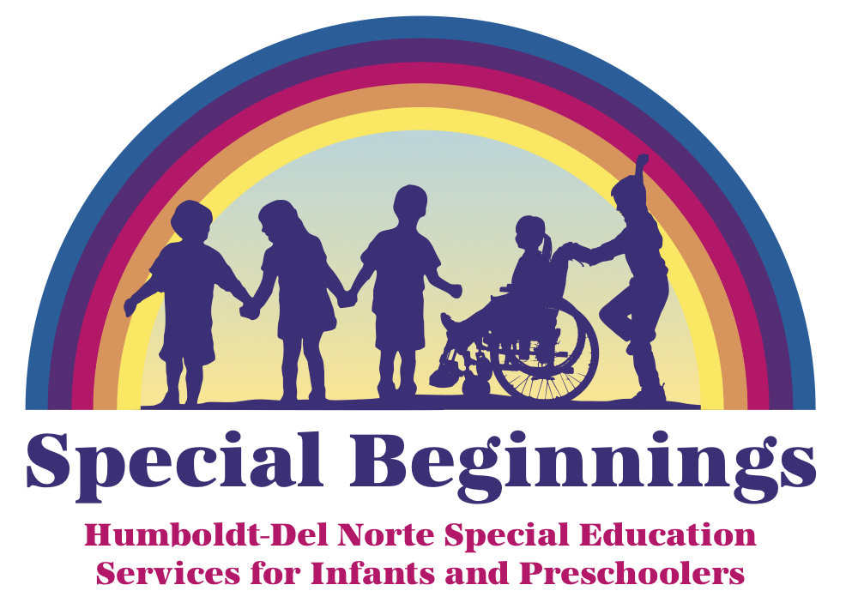 Screening Request
Special Beginnings/ Humboldt County Office of Education
901 Myrtle Ave. Eureka, CA 95501
(707)445-7043 FAX (707)445-7143
Dear Parent/Guardian:
We occasionally receive requests from parents and/or other family members, physicians, preschools, and the Redwood Coast Regional Center for a Special Beginnings Staff Member from the Humboldt County Office of Education (HCOE) to screen children.
Screening would consist of observation at our site or natural environment, asking your child to perform a few learning-related activities such as copying a simple drawing, or answering questions designed to elicit language. Screening could include use of a formal screening tool, depending on your child’s needs. The screening would take place in a designated quiet space at our site.
Screening is a process that a teacher or specialist uses to determine appropriate instructional strategies for curriculum implementation. Screening typically is relatively simple and quick. Screening is not an assessment for eligibility for special education and related services and does not result in a determination regarding a child’s disability and/or eligibility for special programs. If you would like a determination regarding whether your child is eligible for special education, please let an HCOE Staff Member know and we will coordinate with your school district of residence in that process.
This form gives your permission for the HCOE Staff Member to screen your child. We only complete screenings of identified children when we believe the child could benefit from additional instructional strategies.

Child’s Name __________________________________________________________Today’s Date_________________________

Date of Birth_____________ Gender M / F Home School/ District of Residence :____________ School District Documentation Yes NO

Home Address of Child________________________________________________________________________________________

Parent/Guardian’s Name Printed: ______________________________ Phone for Parent/Guardian: __________________________

Best times to call: _________________________________ Ethnicity: __________________________________

Is there a shared custody agreement? (Please Circle) Yes / No Home language:________________________________

Person Requesting Screen:__________________________________ Child’s language:_______________________________

Preschool/Daycare Name & Phone (if applicable): ________________________________________________________________

Address of Site: _______________________________________________________________________________________________

Child’s Days & Hours at Site: _____________________________________________________________________________________

Please circle concerns: Pre-Academics Communication Daily Living Skills Motor Skills Social/Emotional Health Concerns

Concerns related to the child’s education _____________________________________________________________________________

__________________________________________________________________________________________________________
By signing this form, I give the Humboldt County Office of Education consent to observe and screen my child to determine if further assessment is warranted to determine eligibility for special education services. If further assessment is warranted, an additional assessment plan will be provided and consent will be received before assessments are started.
Parent/Guardian Signature: __________________________________________________________________________________
Screening Request Outcome
For HCOE Office Use Only
Admin. Log Date: ______Screen Date/SIS Date of Initial Referral: ___________Screened by:_______________
Screen Recommendation: ___ Referral to Assessment ___ No Further Action; PWN/File Date:____________
___ Re-screen in _____(mo/yr) ___
SIS: District Received Parent Consent (Signed AP):________________________________________________

